(Approx. 537 words)

OpenClipArt
By Cal Esneault, President, Cajun Clickers Computer Club, LA and leader of many Open Source Workshops & SIGs
May 2012 issue, Cajun Clickers Computer News
http://cccclinuxsig.pbwiki.com
www.clickers.org
ccnewsletter (at) cox.net

OpenClipArt is a large compilation of clip art in which images have been released to the public domain (unless specifically stated otherwise), and thus are free to use without any restrictions. Numerous collections are available for free download at OpenClipArt.org. The larger sets of images are in compressed file format (.zip, .gz, .bz2). You have to unpack the compressed files by double clicking on the downloaded package to extract images (note: Windows users may need to install the 7ZIP program to access .gz or .bz2 files).

Images are generally available in .svg vector format or common bitmap formats. LibreOffice programs load all file types, but MS Office programs will not load .svg files. Vector graphic files have the advantage of being editable (can add, delete, change, or move primitive components). The best way to edit them is to install the open source vector editor Inkscape. However, a limited web-based editor Imagebot is available at the OpenClipArt site. Here you can see a chicken cartoon to which I have added several objects using Imagebot. Modified images can be saved to vector or bitmap formats.

Once you have downloaded the images, you can “insert” them into the appropriate document just as you would for any picture. With LibreOffice (or OpenOffice.org),
a better way is to link the images to the Gallery. For example, in LibreOffice, find the small bar directly under the main top panel that has 5 small dots.

Double-click on it to show the gallery (close Gallery with a subsequent double click). You can click and drag on this bar to increase the viewable area. The following illustration shows the word-processor Writer with the Gallery showing between the menus and the text editing area. LibreOffice comes with only a few basic images (background, bullets, ruler, etc.). To add more, click on the New Themes button, give it a new name under the General tab, and then go to the Files tab and link the folder with your images via Find Files.

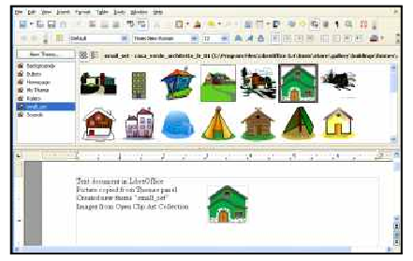
In my example, “small set” is my new theme name. Once the folder is added, it appears in the drop-down list and small thumbnails appear for each image. To add an image to the document, click on it and simply drag it to the appropriate spot.

For Linux users, many package managers will load main OpenClipArt collections for you and put images into OpenOffice.org or LibreOffice. Below is a screenshot of the Gallery that was automatically prepared on my copy of LibreOffice on Ubuntu 11.10.

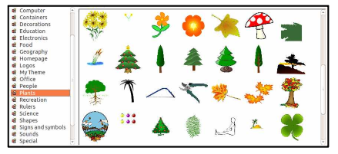
MS Office clipart is generally stated to be for personal or non-commercial use. For other purposes, you are directed to read the EULA or contact Microsoft. Since Microsoft artwork can be from third parties, permission to widely distribute may get complicated. OpenClipArt images have the advantage of being public domain with no restrictions (unless specifically stated). This opensource set is a valuable resource readily available for cross-platform use. Check it out at openclipart.org. New images are added weekly, and there are groups of special topic images (sports, people, seasons, etc.).

